6U 550MM DEEP WALL CABINET - GREY
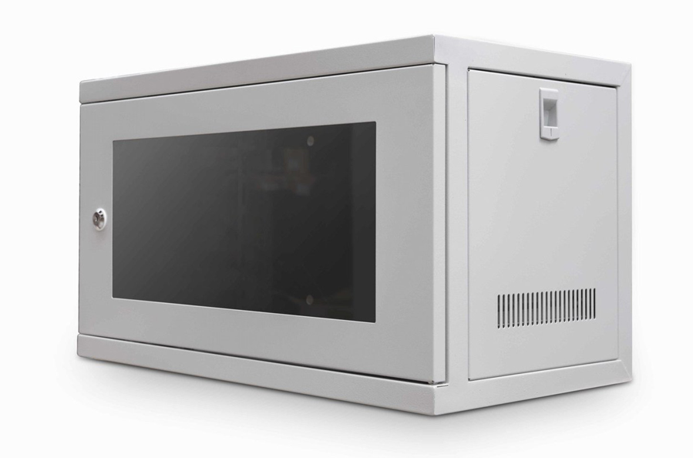

DESCRIPTION

Quality and Security for all your Networking, AV and Data applications;
Exceptional build-quality and a host of features.
Everything you need in a compact, 19-inch wall enclosure.
The new CAB-W6U-EL550G is a feature-rich, small-height and shallow depth
data enclosure, powder coated with a hard wearing grey finish (RAL 7035).
With a 550mm depth (approx), this cabinet is ideal for restricted or tight fitting
areas in which the normal, larger depth cabinets are not required. For example in
residential homes, community areas or remote networking enclosures that do not
need a large amount of enclosure space.
Fully built straight from the box, the CAB-W6U-EL550G features a front and of
course reversible lockable door and front and rear vertical mount posts for secure
equipment deployment.
Equipped with ventilation slots for increased equipment airflow and of course
easy, single person installation makes th CAB-W6U-EL550G the ideal choice for all
your small-scale equipment housing applications.

SPECIFICATIONS
• ETSI 19” front/rear profiles
• Lockable glass door, reversible if required
• Multiple cable entry points
• Wall mountable and easy to install
• Power-coated GREY and robust finish - RAL 7035
• Supplied with a complementary bag of cage nuts and bolts

TECHNICAL INFO
SKU/MPN: CAB-W6U-EL550G
EAN: 8400800031495
Weights: 11.5Kg
Dimensions: 550x550x320mm

FILES
Datasheet - CAB-W6U-EL550G

